React Beginner Roadmap (Word-Friendly Outline)

0. Environment Setup

Install Node.js and npm
Why do we need Node.js
- React is built on JavaScript and runs in a browser, but the development tools (like Create React App, or Vite) require Node.js to run locally
- React app requires Node.js for building, running, and managing dependencies
- Node.js includes npm(Node package Manager), which is used to install libraries and packages (like React, React router, etc.).
Context:
React code itself (JSX + JavaScript) cannot run directly in a browser in its raw form because:
- JSX is not valid JavaScript, browsers do not understand it.
- Modern JavaScript features (ES6 modules, imports/exports) need to be converted for browser compatibility
That’s where development tools comes in
Development tools refer to software that helps create, compile and run React app locally
Examples given: Create React app (CRA) and vite.
These tools do several things:
- Set up the project structure automatically
  - Create folder, files, and configuration so you do not have to manually set up React from scratch.
- Transpile JSX and modern JavaScript
  - Converts JSX and ES6+ code into plain JavaScript the browser can understand.
- Run a development server
  - Opens your app in a browser locally and refreshes automatically when you make change.
- Manage dependencies
  - CRA or Vite use Node.js and npm to install React and others libraries the app needs
In simple terms:
- React = the code you write
- Browser = where the code runs
- Development tool (CRA, Vite) = a helper program that prepares your code so the browser can run it.
- Node.js = the engine that runs the helper program on your computer.

Install code editor (VS Code) and extensions

ESLint
It is code formatter that analyses the code and flag the potential errors, bugs, and stylistic issues. It enforces best practice.

Prettier
It is code formatter that automatically formats your code (indentation, spacing, line length) every time you save.
Prop Tip: Once installed, configure VS Code to run Prettier on save. Go to settings (Ctrl + ,), search for Format On Save, and make sure the box is checked.

React Developer Tools

Browser setup

Google Chrome or modern browser

React Developer Tools extension

1. Creating a React App

Intro
Creating React App means generating the initial project structure, installing dependencies, and preparing a development environment that runs your React code
When you “create a React app,” you are:
- Generating a project folder
The tools create files like:
  - Index.html
  - Main.jsx
  - App.jsx
  - Package.json
  - /src folder
- Installing dependencies
This includes:
  - React ➡️ The main library
  - React-DOM ➡️ connect React to the browser
  - Vite ➡️ builds and runs you app locally
- Setting up the development server
The server:
  - Runs the app locally on localhost
  - Automatically reloads when you save file
  - Show errors directly in the browser
- Preparing the bundling system
The tool configures:
  - JSX ➡️ converted to JavaScript
  - ES Modules ➡️ bundled
  - CSS handling
You do not set any of this manually
Key Vite Commands:
Command | What it does
npm create vite@latest | Creates a new Vite React project
npm install | Installs dependencies
npm run dev | Starts local development server
npm run build | Builds production version
npm run preview | Previews the built app locally

Using Create React App (CRA)

Using Vite (The Modern Standard)
Modern React apps are usually created using Vite (fast, lightweight) or the older Create React App (CRA).
On the terminal, type the following
Answer the prompts: Follow the on-screen instructions, once finished, change the directory to the project folder by typing this in the terminal.
Then to download and install the dependencies, type the following on terminal
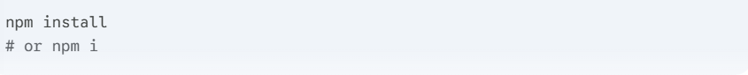
Scaffolding = automatically generating the initial basic structure and require files for a new software project. It’s like setting up the framework or skeleton of building before starting adding walls and firnutures.

Running the development server
  - npm start (CRA)
  - npm run dev (Vite)

2. Project Structure

Default CRA folder structure
  - public/
  - src/
  - package.json
  - node_modules/

Using Vite
Vite sets up a basic structure. The most important folder is in src/, which contains all application code
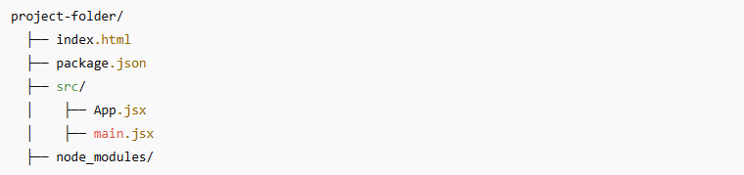

Recommended src/ organization
  - components/ Reusable UI Elements (Buttons, Cards, Forms, Header, Footer)
  - pages/ Top-Level Views/Routes (e.g., Home, About, Dashboard)
  - hooks/ Custom Logic (Reusable use... functions)
  - context/ Global State (Context API setup)
  - api/ Data Fetching/Services (Axios setup, API client)
  - assets/ Static Media (Images, Fonts, SVGs)
  - App.js
Index.html file: with vite, this entry point is outside of the src/ folder, typically in the project root or in the public/
Why this is correct?
  - Build Process Separation: The src/ folder contains files that need to be processed and compiled, and bundled by tools like Babel, Webpack, or vite (e.g., your JSX, JavaScript and CSS
  - Static Assets: The index.html file is a static entry point. It’s the first file the browser loads. It has minimal code.
  - Injection Point: Vite injects the compiled JavaScript bundle into this index.html file at build time. Because it’s a static template that hosts the final application.
In short: index.html is the container, and the bundled code from src/ is the application poored into it.
The Pages Folder (pages/) inside src/:
The components inside pages/ folder are the high-level-views that are rendered based on the current URL. It’s main job is to be imported by App.jsx (or a similar routing) and act as wrappers that assemble smaller components into a full screen.
The component Folder (components/)
These are the small, reusable UI elements that the pages/ components import and use.
Here is how the imports typically flow in a routed application:
  - main.jsx imports and renders App.jsx.
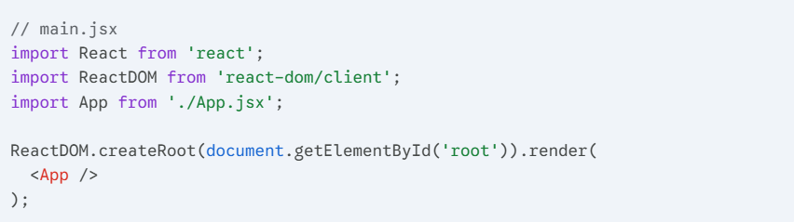
  - App.jsx imports the Router and components from pages/.
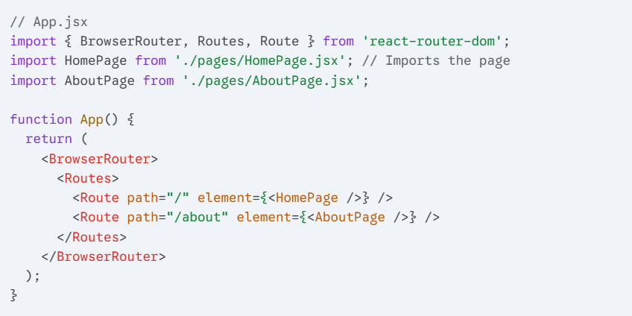
  - pages/HomePage.jsx imports components from components/
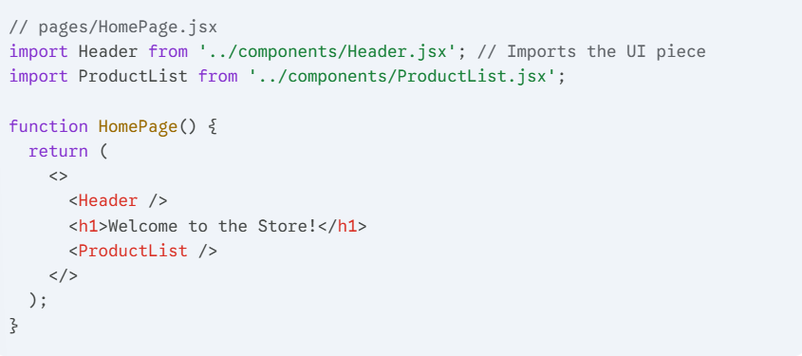

3. React Basics

What is React
React is JavaScript library for building user interfaces, mainly for web application. It focuses on creating fast, interactive and reusable UI.
- React is Component-Based:
- React app are built using components
- A component is like self contained piece of IU (like button, header, form, or page section)
- Component can be reused, which reduces code duplication and makes maintenance easier.
- JSX (JavaScript XML)
- React uses JSX (looks like HTML and JS) to describe the UI.
- JSX is optional, but it makes code easier to read and write
- Virtual DOM
- React keeps a lightweight copy f the DOM (virtual DOM) to minimize expensive updates
- When data changes, React compares the Virtual DOM with the real DOM and only updates what’s necessary

Virtual DOM vs Real DOM
  - Real DOM
    - DOM (Document Object Model) represents the structure of the webpage as a tree of HTML elements
    - It directly interacts with the browser
    - Updating is slow for large application as every time you change something, the browser re-renders the entire DOM subtree where the change happened
    - It can lead to performance issues if you have frequent update.
  - Virtual DOM
    - React introduces the Virtual DOM, which is an in-memory lightweight copy of the real DOM
    - When state or props changes in a component, React updates the Virtual DOM first, not the real DOM.
    - React diffs (compares) the new Virtual DOM with the previous version
    - React calculates the minimum changes needed to update the real DOM
    - React applies only those changes to the real DOM
    - This makes UI updates fast and efficient
Analogy
- Real DOM: A paper document. Every time you want to change a word, you rewrite the whole page
- Virtual DOM: A digital copy of the paper. You make changes on the digital copy and only the necessary parts are updated on the real paper.

JSX syntax and rules

What is JSX
It stands for JavaScript XML
- It looks like HTML
- It lives inside JavaScript
- It gets compiled into JavaScript functions by built tool like Babel, vite, etc.
- Browsers cannot read JSX directly, it must be compiled
This code:
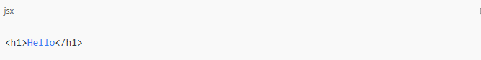
Gets converted to this:
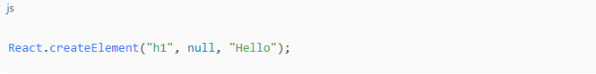
H1: Type
Null: props
Hello: children
Props: stands for properties, they are inputs passed to the component. They work in similar way as argument in function and they allow component customization and configuration.

JSX Rules

Rule 1: JSX must return one parent element
❌This is invalid, because React does not know which element is the top-level wrapper
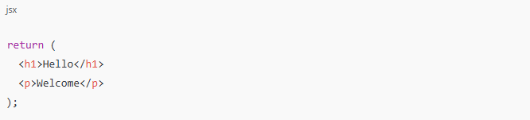
✅This is valid as we have div the parent element, the top-level wrapper
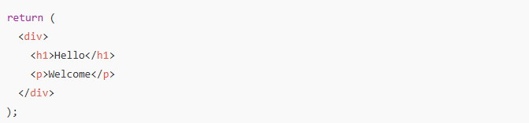
Or using a fragment <></>
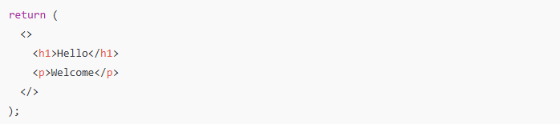

Rule 2: JSX attributes use camelCase
HTML | JSX
class | className
for | htmlFor
onclick | onClick
tabindex | tabIndex

Because JSX is JavaScript, not HTML. JavaScript variable use camelCase

Rule 3: JavaScript expression must be wrapped in { }
We can write JS inside JSX, but only inside curly braces {}
✅Valid:
JSX allows any JavaScript expression, but NOT statments (if, for, while).

Rule 4: JSX must be closed properly
HTML lets you omit closing tag like in img
❌Invalid:
✅Valid:

Rule 5: You cannot use conditionals directly in JSX (no if, else)
❌Invalid:
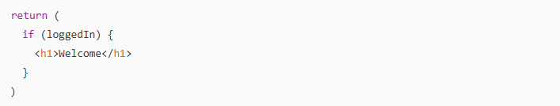
✅ Valid:
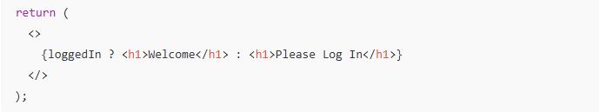

Rule 6: JSX cannot return object directly
❌This is invalid:
✅This is valid:

Expression VS Statements in JSX
JavaScript Expression | JavaScript Statement
2 + 2 | if()
"Hi" | for()
count * 10 | while()
loggedIn ? "Yes" : "No" | let x = 5
JSX only accepts expressions, not Statement

JSX returns React Elements (Not HTML)
This:
Does not create HTML, It creates a React element object, React later converts that object into DOM nodes

Comment in JSX
JSX comments syntax:
Inside JS:

JSX must be inside a component function
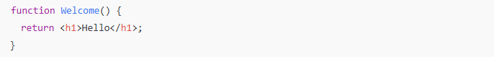

JSX Children
Children are simply nested JSX
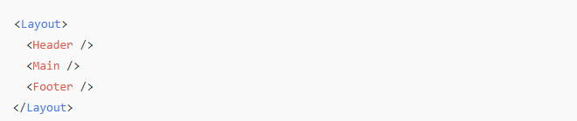
This is possible because children are passed automatically as props.children

Functional components
It is a JS function that returns JSX
It :
- Accepts props (property, just like argument in the function)
- Returns UI (JSX)
- Renders on the screen
- Can use hooks (like useState, useEffect, etc)
Functional component structure:
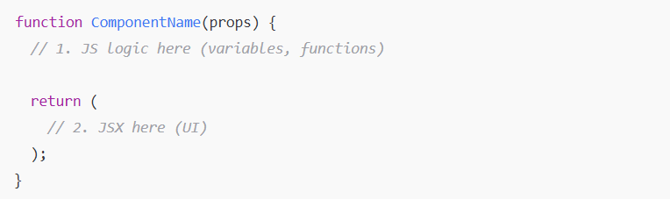
Functional component with Props:
Components can receive data via Props
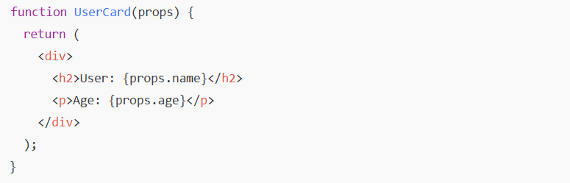
Using the component
name=”Ashia” becomes props.name
age={21} becomes props.age

Props

What props really are
Prop is input to a component, it’s the same concept as argument in a function.
When data passed to a component like this:
React collects model="Corolla" and gives it to the component as an object called props.
So inside component:
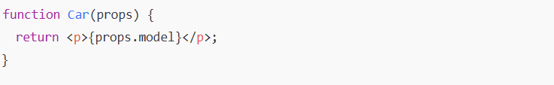
Internally, props is just a JavaScript object:
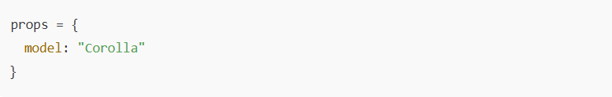

Why React uses props
Props allows component to:
➡️Receive data
➡️Change their behaviour based on that data
➡️Reuse the same component many times with different values
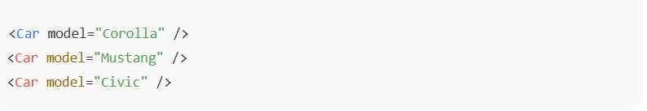
One component ➡️ Three different outputs.
This is reusability, a major React advantage.

Props vs State
Props are read-only:
You cannot change props inside a component.
Props are input, not something to modify
If you want to change data ➡️ you’ll use state, not props.

Props flow (one-way data flow)
Data always moves:
Parent ➡️ Child
Never the other way around
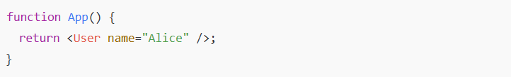
- App is the parent
- User is the child
- Data flows downward
React never allows Child ➡️ Parent by default

Destructuring
Instead of writing:
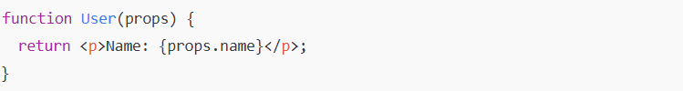
You can write:
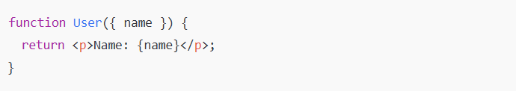

Default props
Used when parents forgets to pass a prop.
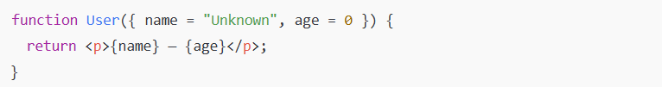
Now:

Props type checking (optional but useful)
Passing Numbers, String, Booleans, Arrays, Objects
React allows many prop types
- Strings
- Numbers
Use {} for numbers
- Booleans
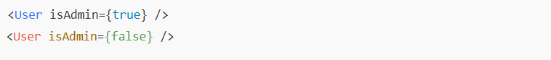
Shortcut:
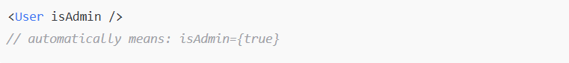
- Arrays
- Objects

Passing functions as props
Parent ➡️ gives function to child
Child ➡️ runs that function
Parent:
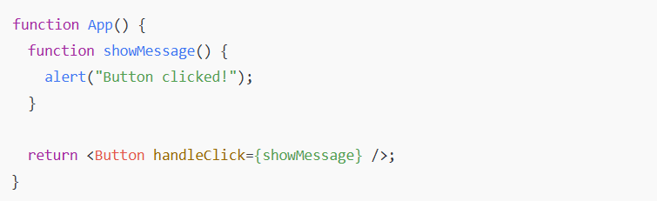
Child:
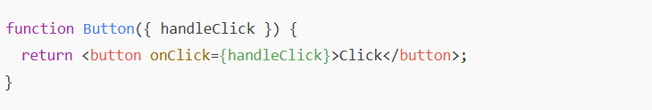

Children prop
When you write:
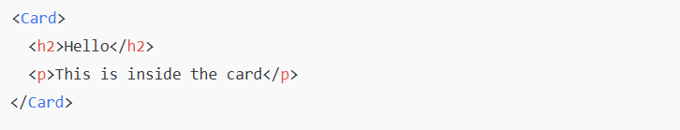
Everything between <card>...</card> becomes props.children
Card component:
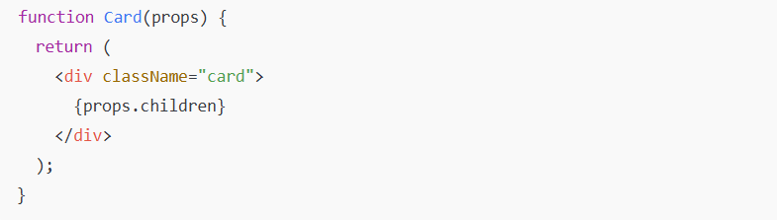

useState hook

what is state in React?
Components often need to change what’s on screen as result of an interaction. Think of state like data that changes over time in your app and affects what the user sees
For example:
- A counter that increases when you click a button
- A text input where the user types something
- A toggle (like switch) that shows “on” or “off”
To update UI correctly in React you need:
- Data that survives to re-renders
- A way that tell React to re-render when the data changes

What useState gives you
It provides both:
- A state variable that keeps its value between renders
- A setter function that updates the value and triggers a re-render

Anatomy of useState
When you call useState, you are telling React that you want component to remember something:
In this case, you want react to remember index
The only argument to useState is the initial value of your state variable. In this example, the index’s initial value is set to 0 with useState(0).
Every time the component renders, useState gives you an array containing two values:
- The state variable (index) with the value you stored.
- The state setter function (setIndex) which can update the state variable and trigger React to render the component again.
When you call the setter SetIndex(..) , React updates that state and re-renders the component so that the UI reflects the new state.
Whatever value you pass into setSomething replaces the current state.

What is a Hook
Any other functions starting with use is called a Hook
Hooks are special functions that are only available while React is rendering.
Hooks function can only be called at the top level of your components or your own Hooks. You cannot call Hooks inside conditions, loops, or other nested functions.

Updating the sate based on previous state
Suppose the age is 42. This handler calls setAge(age + 1) 3 times
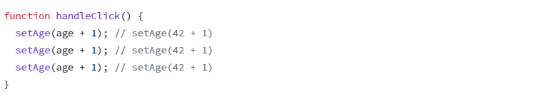
However, after 1 click, age will only be 43 rather than 45. This is because calling set function does not update the age state variable in the already running code.
How to fix this:
Pass an updater function to the setter
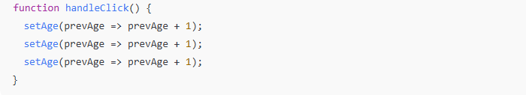
The prevAge is guaranteed to be the latest state, even multiple updates are queued.

Updating Checkbox (boolean)
liked state variable holds a Boolean. When you click the input, setLiked updates the liked state variable with whether the browser checkbox input is checked. The liked is used to render the text below checkbox.
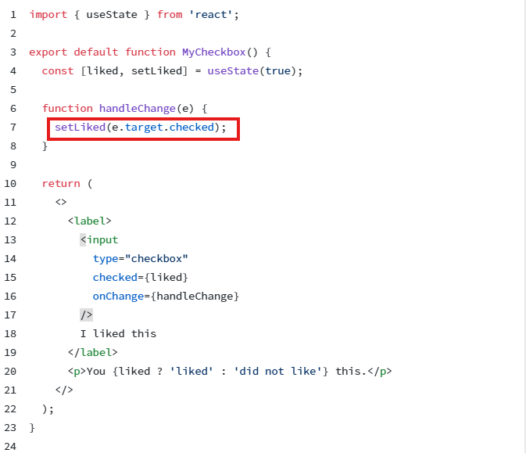
e.target.checked is just Boolean value of the checkbox’s current checked state at the moment of the change event fires.

Updating objects and arrays in state
- Do not change the objects or arrays that are in state
- Always copy them
- Change the copy
- Then set the new copy as state
Example: Form (object)
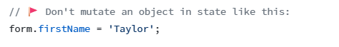
Instead replace the whole object by creating a new one:
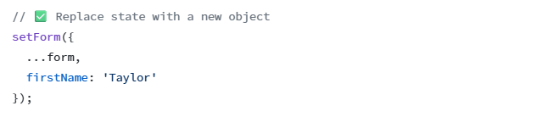
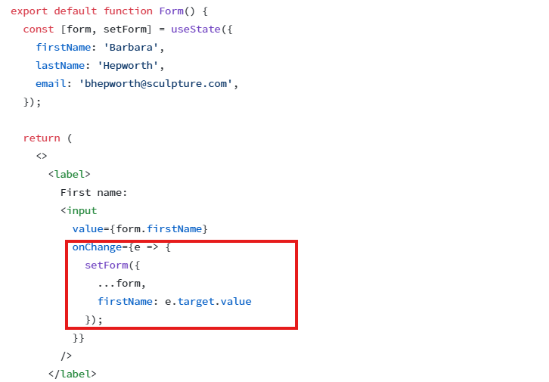

Updating List(array)

Event handling (Responding to events)
Event handlers are your function that will be triggered in response to user interactions like clicking, focusing on form inputs, and so on.

Adding event handlers
To add an event handler, you will first define a function and then pass it as a prop to the appropriate JSX tag.
This button does nothing
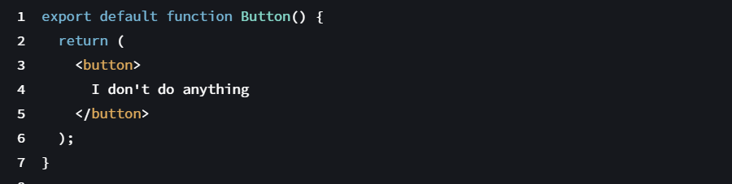
We can add event handler to it when user clicks following these 3 steps:
- Declare a function called hadleClick inside Button component
- Implement the logic inside the function
- Add onclick={handleClick} to the button JSX
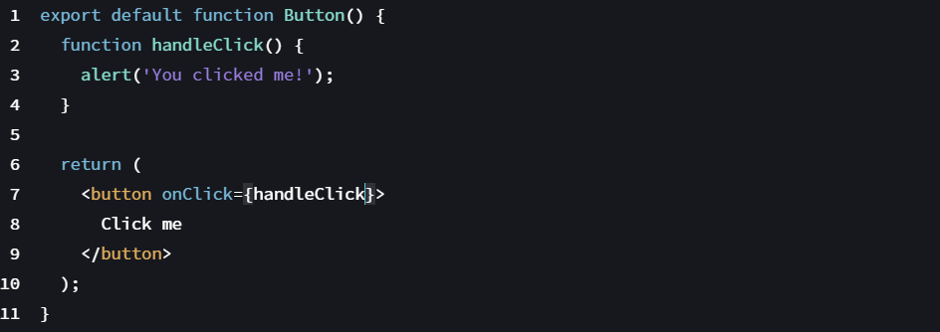

Reading props in event handlers
Because event handlers are declared inside a component, they have access to the component’s props.
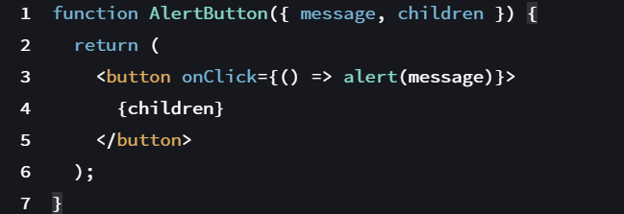
This lets two buttons show different messages.

Passing event handlers as props
The parent component specifies a child’s event handler
To do this:

- The parent component defines a function
- The parent passes that function down to the child component as prop
- The child uses that prop as its event handler

Naming event handler props
By convention, event handler props should start with on, followed by a capital letter.
For example: onClick, onSmash...
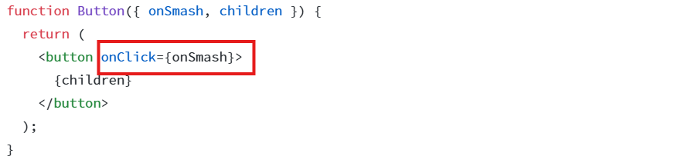

Event propagation
The event propagation means: when you click something in the browser:
- The event happens on the exact element clicked (such as <button>).
- Then the event bubbles upward to its parent, then to the parent’s parent, and so on.
The click travel like this:
Every element along the way gets a chance to run its own onClick handler.
Take a look a below structure:
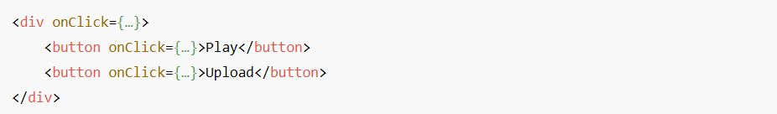
Each button has its own onClick. The div also has its own onClick.
When you click a button:
- The button’s onClick runs
- Then the event bubbles up to the parent div and triggers its onClick.

Stopping propagation
When we talk about event handling, two key concepts come up:
- Event handler: the function that runs when event occurs.
- Event object: an object automatically passed to function containing all the details about the event
Event handler receive an event object as their only argument. By convention, it’s usually called e, which stands for event.
If you want to prevent an event from reaching parent components, you need to call e.stopPropagtion() as shown in component below.
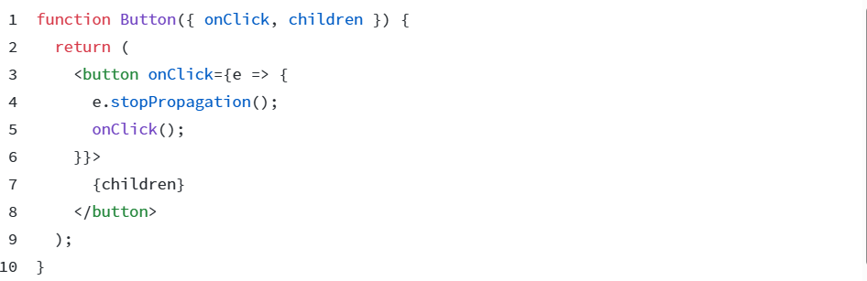

Preventing default behaviour
some HTML element have built-in action when certain events happen. For example:

Element | Event | Default behavior
<form> | submit | Reloads the page (sends form data)
<a> | click | Navigates to the link in href
<input type="checkbox"> | click | Toggles the checkbox
Browser does this automatically unless you prevent it.
To prevent the default behaviour: we call e.preventDefault() on the event object.
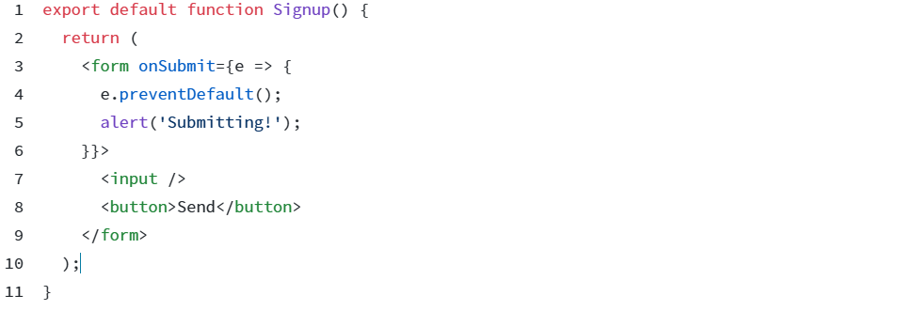

Pitfall
Don’t confuse e.stopPropagation() and e.preventDefault(). They are both useful, but are unrelated.

4. Component Hierarchy

Parent → Child communication via props

Conditional rendering
You can write this as an if/else statement like so:
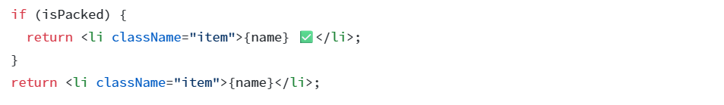
The code above is redundant, it shows duplication as both of conditional branches return <li className="item">...</li>:
The problem is: what if you want to change the className ? You’d have to do it in two places in your code. Solution: use ternary operator.
Conditional (ternary) operator (? :)
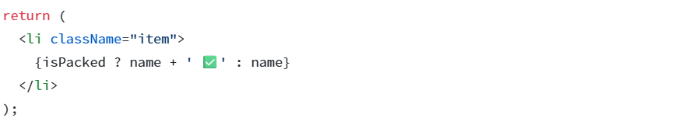

Logical AND operator (&&)
It says, when the condition is true render something otherwise render nothing.
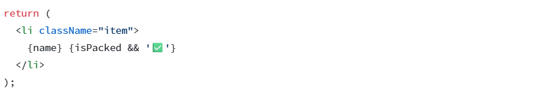
You can read this as “if isPacked, then (&&) render the checkmark, otherwise, render nothing”.

Rendering lists with .map()
We will use filter() and map() with react to filter and transform array of data into an array of components.
Rendering data from arrays
Say that you have the following list of content.
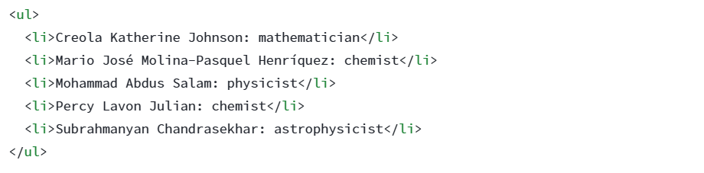
The only difference among those list items is their contents, their data.
Here is short example of how to generate a list of items from an array.
- Move the data into the array:
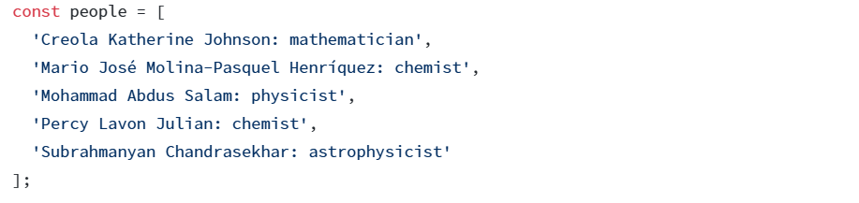
- Map the people members into a new array of JSX nodes, listItems:
- Return listItems from your component wrapped in a <ul>:
Filtering arrays of items
This data can be structured even more.
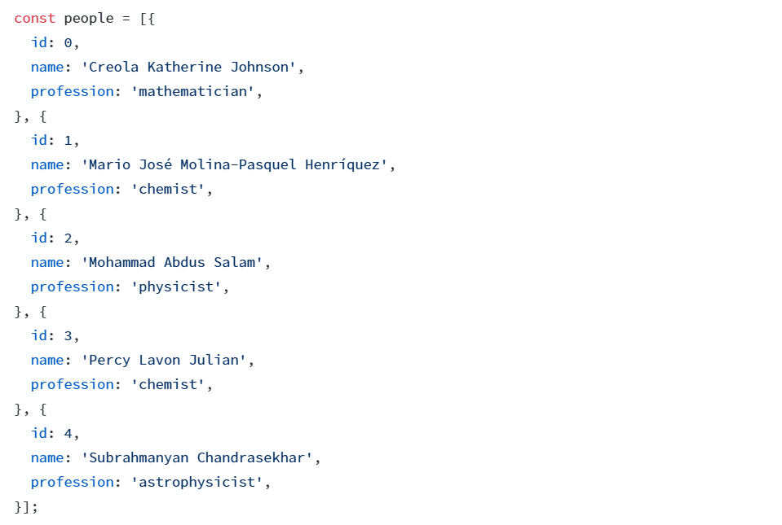
Let’s only show people whose profession is chemist
Here is how to do it:
- Create a new array items where profession is chemist.
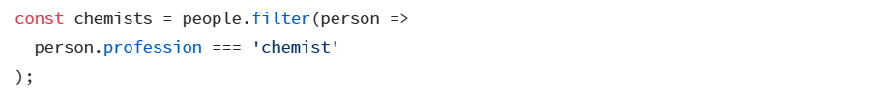
- Map over chemists
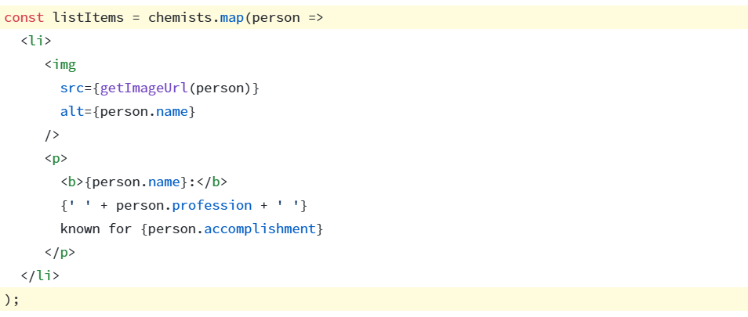
- Return the listItems from your component
Pitfall (common mistake)
Arrow function implicitly return the expression right after =>, so you didn’t need a return statement:
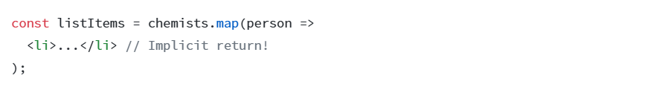
However, you must write return explicitly if your => is followed by a {curly brace!
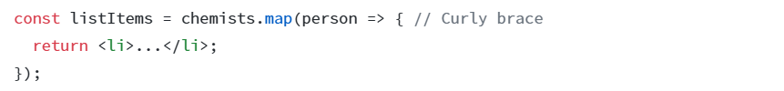
Keeping list items in order with key
You need to give each array item a key, a string or a number that uniquely identifies it among other items in that array.

Using unique key props

5. Side Effects

What is side effect?
In react, effect is anything that happens outside the component rendering process. That is anything React does not handle directly as part of rendering the UI.
Common examples of side effects in React include:
- Data fetching: Making API calls to retrieve or send data to server
- Updating the browser’s tab title.
- Getting user’s location.
- DOM Manipulation: Directly interacting with the browser’s Document Object Model, such as changing an element’s style or adding/removing elements.
- Subscriptions: setting up connections to external data sources like WebSocket or event listeners.
- Timers: Using setTimeout or setInterval for delayed or repeated actions.
- Local Storage Interaction: Reading from or writing to the browser’s local storage.
Important: Rendering JSX is not a side effect. Rendering is pure, it only depends on props and state. Side effects are anything that cannot be done during render safely.

useEffect hook

what is useEffect
useEffect is React’s way to handle side effects in functional components. useEffect lets you run a function after the component renders or update

Basic syntax
useEffect accepts 2 arguments: the second argument is optional
- Function
- Dependency
- The function inside useEffect runs after the component renders.
- You cannot run side effects directly in the main function body if they need the DOM or async operation, React warns you about it.

Why you cant just do side effects in the component body
In React, a component is just a function.
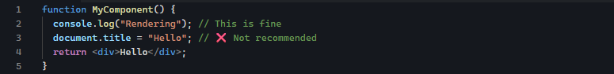
React runs the component many times:
- Initial render
- Re-render when props or state change
Manipulating DOM or fetching data directly in the function body will happen every render, which can cause bugs.

How useEffect fixes this
useEffect tells React: Run this code after render
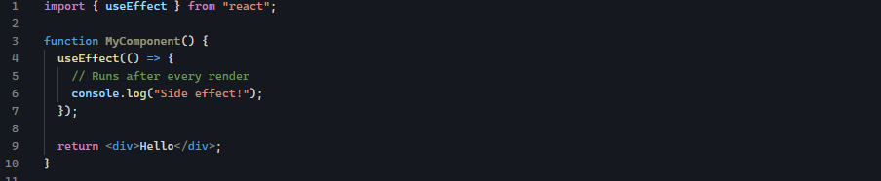
- The component renders ➡️ React updates the DOM ➡️ then your useEffect runs
- This is safer for DOM manipulation, async calls, subscriptions, timers, etc.
✅ Anything inside useEffect runs after the component renders and the DOM is updated.

Simple Example
Imagine you want to log something to the console every time the component renders:
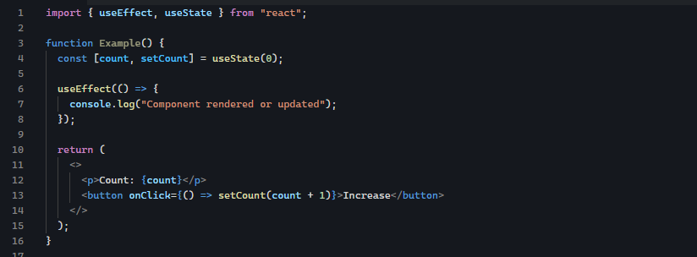
What happens here:
- On the first render: console.log runs
- On every click (state change ➡️ re-render): console.log runs again.

Key points about useEffect
- Runs after render ➡️ the DOM is updated first
- By default, runs after every render
- Can perform async operation like fetching data
- Can clean up resources.

Dependency array

What is it?
The dependency array is the second argument of useEffect. It controls when the effect runs


What it does?
- React checks the values inside the array on every render.
- The effect only runs if any value in the array has changed since the last render.
Think of it as: Run this effect only when these specific values change.

No dependency array
- Runs after every render, because React has no clue which values you care about.

Empty array []
- Runs only once, right after the first render.
- Useful for componentDidMount logic, like fetching data once.

Specific dependencies
- Runs only when count changes.
- If other state changes (like different variable), the effect does not run.
This is important for performance: you do not want unnecessary effects on every render

Cleanup functions

What is cleanup function
Sometimes, the effect you set up persists beyond the component’s rendering lifecycle such as:
- Event listeners like window.addEventListener
- Timers like setTimeout or setInterval
- Websocket or server connections.
These things keep running even if your component is removed.
If they are not stopped, they can:
- Cause memory leaks
- Run code unnecessarily
- Try to update a component that no longer exists
Cleanup function = a function that cleans up these ongoing things when component is reoved or updated

How cleanup function works in useEffect
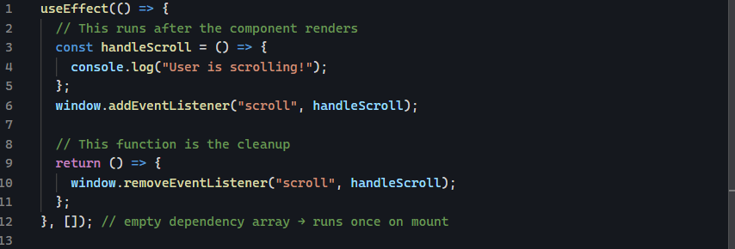
What is happening here:
- Component mounts ➡️useEffect runs ➡️ scroll listener is added.
- User scrolls ➡️ handleScroll runs.
- Components unmounts ➡️ React calls the cleanup function ➡️ listener is removed.
This prevents the listener from running after the component is gone

Timer example
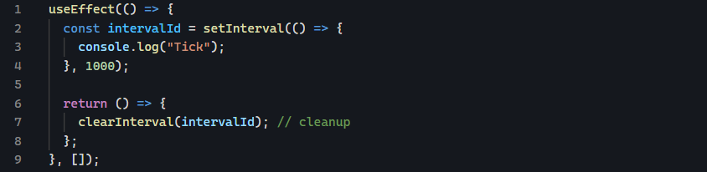
setInterval keeps running forever unless you clear it.

API calls inside useEffect

Timers and subscriptions

6. Forms

Form in React
In React, Forms allow users to enter and submit data through inputs such as text fields, checkboxes, radios and dropdowns.
Forms are handled differently in React compared to plain HTML, because React wants to keep the UI and data always in sync.

Controlled components
A controlled component is a form element whose value is controlled by React state. Meaning: The component’s value is always driven by JavaScript state, not by the DOM.

Why use controlled component
- React always knows the value
- Easy to validate input
- Easy to modify input on the fly
- Predictable data flow

Example: Controlled text input
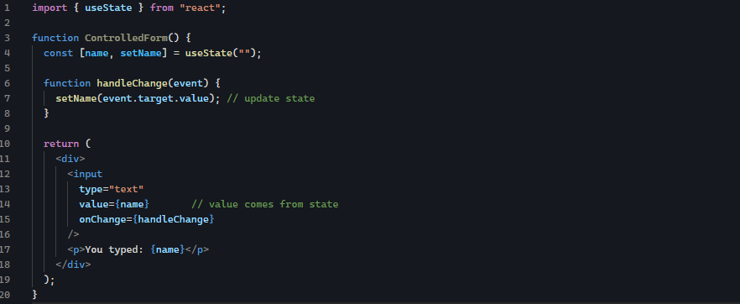

How controlled component work
- User types something
- onChange fires
- state updates
- input displays new value from the state

Uncontrolled components (optional)
Uncontrolled components allow DOM to handle form data instead of React.
You access data using refs instead of state
Used when:
- you do not need React to track every keystroke
- legacy code
- performance matters for very large forms

example: uncontrolled unput
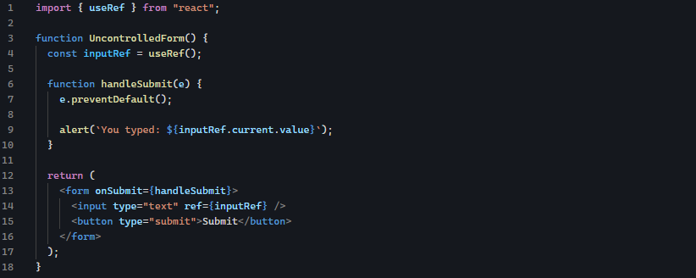

Difference
Feature | Controlled | Uncontrolled
Data stored in | React state | DOM
Validation | Easy | Harder
Re-render control | Yes | No
Best for | Most apps | Rare cases

Handling input changes
Every form element has a value that needs an onChange handler

Text input
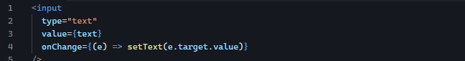

Checkbox input
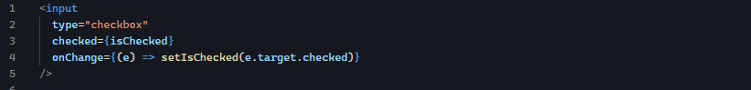

Radio input
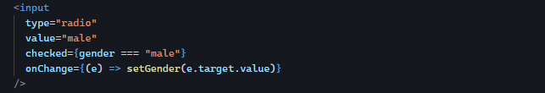

Select dropdown

Textarea
A textarea form’’s element is used when users need to enter multiple lines of text, such as:
- comments
- messages
- descriptions
- posts
- feedbacks
it behaves almost like normal text input but there are a few important details

controlled text area
just like controlled inputs, a controlled textarea stores its value in React state
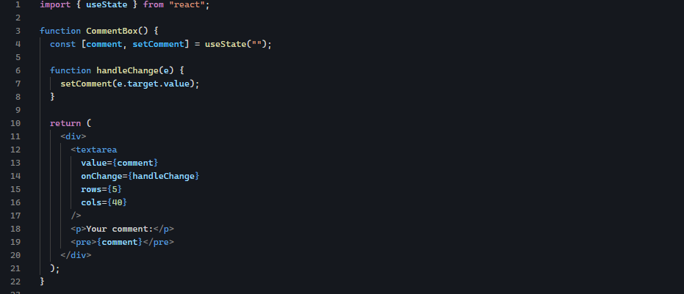

Default value vs value
In HTML, textarea uses inner text
In React:
❌ This does not work
Instead use:
Or preferred

Form submission
React from use onSubmit to submit form.
Important: always call event.preventDefault() to stop page reload

Basic from submit example
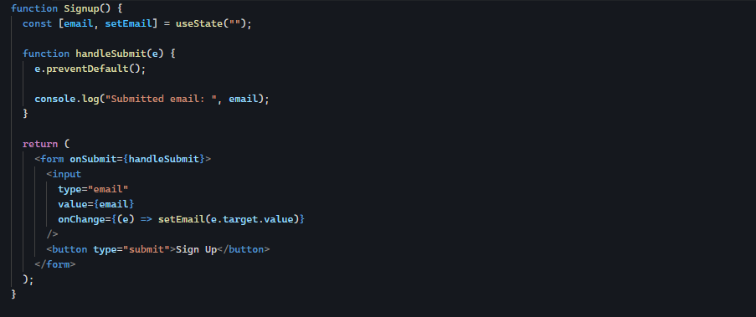

Input validation
Validation ensures user input is correct before storing or submitting
Common validation types:
- required field
- length limits
- email format
- number range
- custom rules

example: validation in React
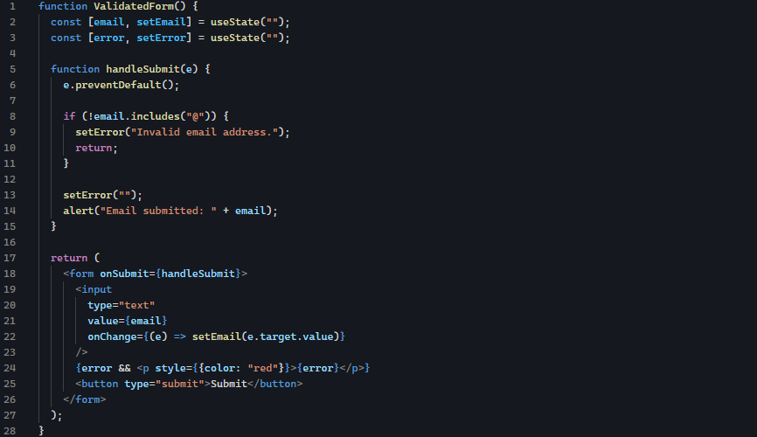

Realistic validation example
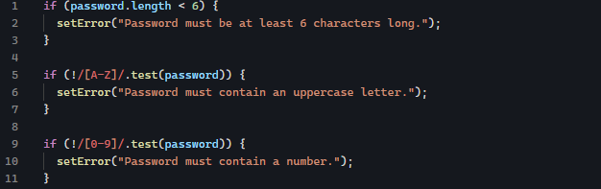

7. Routing

Installing React Router

BrowserRouter

Routes and Route

Navigation using Link and NavLink

Nested routes

Dynamic routes

8. State Management

Lifting state up

Prop drilling

Context API for global state

Optional: Redux Toolkit introduction

9. Advanced Hooks

useReducer for complex state

useMemo for expensive calculations

useCallback for memoizing functions

useRef for DOM references

useRef
It is React Hook that gives you a special object which survives re-render and lets you store something that does not need to trigger UI updates when it changes.
- it returns a single object with a .current property
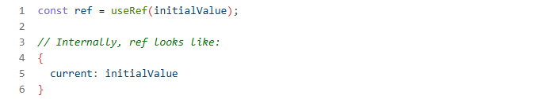
- You read it from ref.current
- You write to it with ref.current = something
- Changing ref.current does not re-render the component
- changing .current does not re-render the component.
- Use it to:
- Access DOM elements (inputs, divs)
- Store mutable values that persist across renders (timers, previous values)
- Work with uncontrolled inputs (read their value via refs on submit)
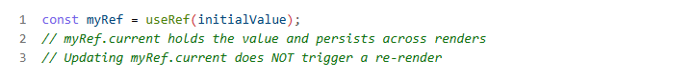

useRef returns and object
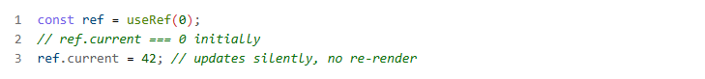

useState and useRef
Both useState and useRef survives re-renders.
When a component re-renders, local variable reset, but state and refs persist. So useState and useRef both keep their values across renders

how do you reference values using Refs
in React, there may be situations where you need direct access to a DOM element. That’s where ‘refs’ come in handy.
In vanilla JavaScript, we used the getElemenById() and querySelector() method to access DOM elements. But in React, we use refs

How to create and user refs
- Import hook from React:
- Create a variable to hold the ref with the initial value of the ref inside the useRef hook. Here sectionRef is initialized to null
- Finally, attach the ref variable to the element in your JSX by using the ref attribute
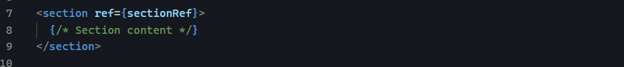
If you log ref to the console, you will see an object with the current value, in this case null
the subsequent values of the ref depend on the component lifecycle.
For example:
- The initial value of sectionRef will always be null because that’s what it was initialized to.
- After the component is mounted, the value of the ref will be the section element the ref is attached to.
- If the component is unmounted, the ref’s value goes back to the initial value of null
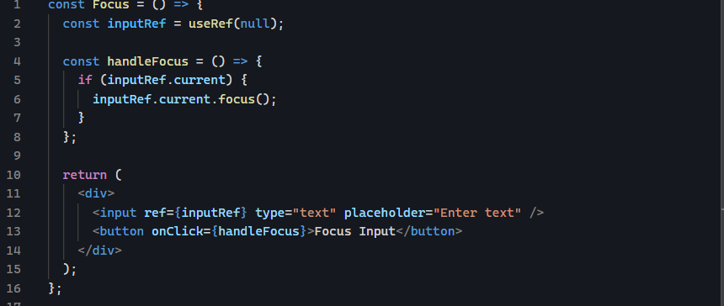

Best practices for working with refs:
- Use refs mainly to interact with the DOM. You can also use them for mutable data, but state is a better choice for that.
- Do not use ref for basic state management, that is what useState is for.
- Make sure yo check ref.current exists before accessing its properties. Here is how to do that
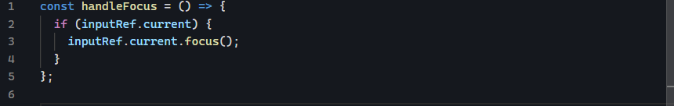

Their difference: Re-render behaviour
- useState: when you update state, React re-renders the component.
- useRef: when you update ref.current, React does not re-render.
Think of it this way:
- useState ➡️ I want React to know this changed and update the UI.
- useRef ➡️ I want to remember this value, but I do not need the UI to change
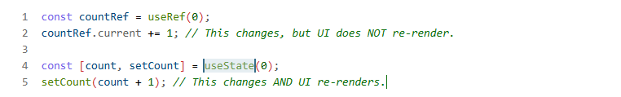

React.memo

10. Styling React Components

Inline styles

CSS modules

Styled Components

Conditional styling

Optional: Tailwind CSS

11. Working with APIs

Fetching data with fetch

Using axios

Handling loading, success, and error states

Updating state with API data

12. Performance Optimization

React.memo

Lazy loading components

Code splitting

Avoid unnecessary re-renders

13. Optional Advanced Topics

Higher-Order Components (HOCs)

Render props

React Portals

Error boundaries

Introduction to Next.js

14. Projects (Practice)

Counter app

Todo app

API data app (weather/movie)

Multi-page routing app

Cart or e-commerce mini-app

Portfolio website

15. Deployment

Deploy to Vercel

Deploy to Netlify

Optional: GitHub Pages

16. Final Steps

Build small projects to reinforce concepts

Refactor projects using advanced hooks and context

Explore testing with Jest and React Testing Library

